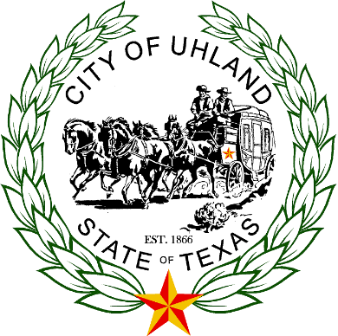

Special Meeting of the Board of Aldermen of the City of Uhland, Texas October 18, 2017 at 6:00 p.m. at Uhland City Hall, 15 N. Old Spanish Trail, Uhland, Texas, 78640.
This City of Uhland provides unrestricted access for the disabled.
This Notice is posted pursuant to the Texas Open Meeting Act. (TEX REV. CIV. STAT. ANN, art 6252-17 (Vernon Sup. 1990).

- Call to order, Mayor Bryan Geiger.
- Roll call.
- Pledges of Allegiance - United States and Texas
- Public Comments (3 minutes per comment)
- Approval of Minutes of October 4, 2017

- Discussion and possible action on application, Cotton Gin Estates 22.674 acres Phase 2-1A Final Plat not to include construction plans.
- Discussion and possible action on application, Cotton Gin Estates 19.138 acres Phase 2-2 Final Plat not to include construction plans.
- Discussion on City of Uhland grants.
- Discussion and possible action on Confidentiality Agreement between the City of Uhland and Cotton Gin Utility LLC.
- Discussion on Tri-Party Agreement between Walton Texas, LP and Hays County and Amendments to Development Agreement with Walton Texas, LP, Walton Caldwell Ranch and WCR Development Sub., LP.
Meeting adjourns.

The Board of Aldermen reserves the right to adjourn into executive session at any time during the course of this meeting to discuss any of the items listed above, as authorized by Texas Government Code Section 551.071 (Consultation with Attorney), 551.072 (Deliberations about Real Property), 551.073 (Deliberations about Gifts and Donations), 551.074 (Personnel Matters), 551.076 Deliberations about Security Devices), and 551.087 (Economic Development). In compliance with the Americans with Disabilities Act, the City of Uhland will provide for reasonable accommodations for persons attending City Council meetings. To better serve you, requests should be received 48 hours prior to the meetings. Please Contact Karen Gallaher, City Administrator, at 512-398-7399

Please contact City Hall at (512) 398-7399 for further information. Braille is not available. Our email address is city@uhlandtx.us.
I certify that this notice was posted on the bulletin board outside the Uhland City hall the on the ________day of _________, 2017 at ____________ a.m. / p.m. Karen Gallaher, City Administrator ______________________________.

I certify that this notice was removed from the bulletin board outside the Uhland City Hall on the ________day of______________, 2017 at __________a.m. / p.m. Karen Gallaher, City Administrator ______________________________.

